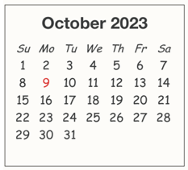
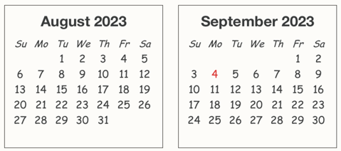
2023-2024 Youth Faith Formation Calendar

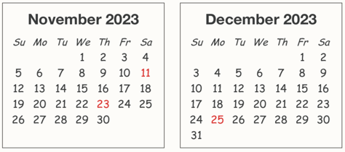

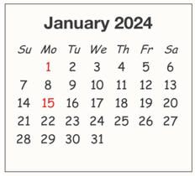

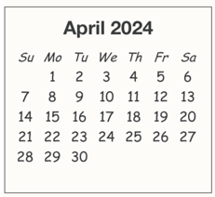
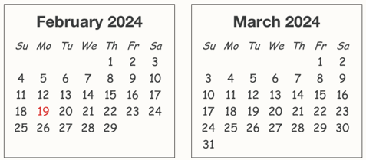

31

= Youth Faith Formation (YFF) on-site sessions
- Wednesday session: students meet in lower level classrooms 6-7 pm; parents join students
for family faith gathering in the Hermes / Media Center 7-7:30 pm
- Sunday session: students meet in lower level classrooms 9:30-10:30 am; parents join students
for family faith gathering in the Hoffman Center 10:30-11 am
= Catechist/YFF team planning sessions on designated Monday evenings 7-8:00 pm
= Family Mass and pot-luck dinner after the 4:00 pm Mass
= 1st Sacrament events (for students celebrating their 1st Reconciliation & Communion)
- Parent Information session on designated Tuesday evenings 7-8 pm
- Parent & Child retreats on designated Saturdays 9-11 am (details communicated separately)
- Parent & Child 1st Communion rehearsal on designated Tuesday 6-7 pm
- First Sacrament events on designated Saturday mornings (details communicated separately)

