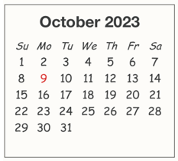
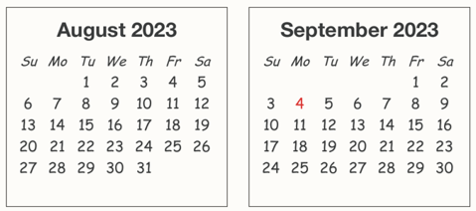
2023-2024 Youth Faith Formation Calendar – A Light Unto Our Path

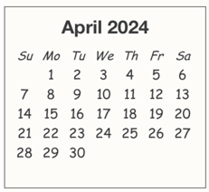
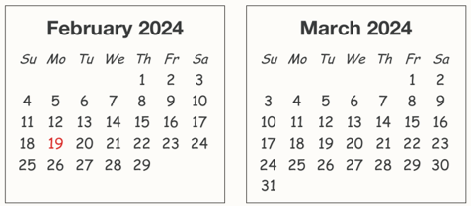

31
1

= A Light Unto Our Path (special needs program) meets in room 122
- ALUOP / Catechist team planning session on designated Monday evenings 7-8 pm
- ALUOP Family sessions the third Wednesday of each month 6-7 pm

